International Journal of Advances and Applications in Convergent Studies & Transdisciplinary
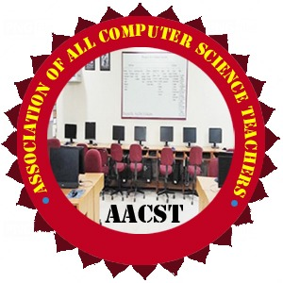
(IJ-AACST)
Bridging Discipline Bridging Knowledge

Website: www.aacstij.org | Email: journaleditor@aacstij.org

Title of Paper
Author Name¹*, Dr. Author Name²
Affiliation of Author(s)
¹Department of Education, University of Pune, India, abc.xyz@gmail.com
²School of Computer, Sharada University, India, bbc.xyz@gmail.com

ORCID (Corresponding Author): https://orcid.org/0000-0002-1234-5678 (It is optional)

ABSTRACT
This is a sample abstract. It should summarize the research objectives, methods, key findings, and conclusion in 150–250 words.
KEYWORDS: Provide 3–6 relevant keywords in alphabetical order for indexing and searchability.
1. INTRODUCTION (Font size 12, Left Alignment).
Describe the background and purpose of the study (Font size 11, Justified Alignment).

2. LITERATURE REVIEW / RELATED WORK
Discuss relevant previous work with proper citation.

3. RESEARCH METHODOLOGY
Explain the methods used.

4. RESULTS AND DISCUSSION
Present and interpret the findings.

5. CONCLUSION AND FUTURE SCOPE
Summarize results and propose future work.

6. CONFLICT OF INTEREST (CoI) (Optional, only for Funding)
Authors must declare any financial or personal relationships that could influence the work or its evaluation.

7. REFERENCES
Authors must follow a subject-appropriate referencing style consistently throughout the manuscript. The referencing format should align with the conventions of the author’s academic discipline or faculty. Commonly accepted styles include:
- APA (Social Sciences, Education),
- IEEE (Engineering, Computer Science),
- MLA (Languages like English, Hindi, Sanskrit, etc.),
- Chicago (History, Philosophy), etc.

8. ACKNOWLEDGMENT (Optional)

Mention any contributions or support received, especially financial or institutional assistance.

9. ABOUT THE AUTHOR(S) (Optional)
Brief bio and affiliation of each author in 50 words.

